Host a static Website on s3

**Step 1 : create an s3 bucket**

* Go to you AWS console and type s3 on your search bar.
* Give a name to your Bucket, and rest we will keep everything as default.
* Click on “create Bucket”.

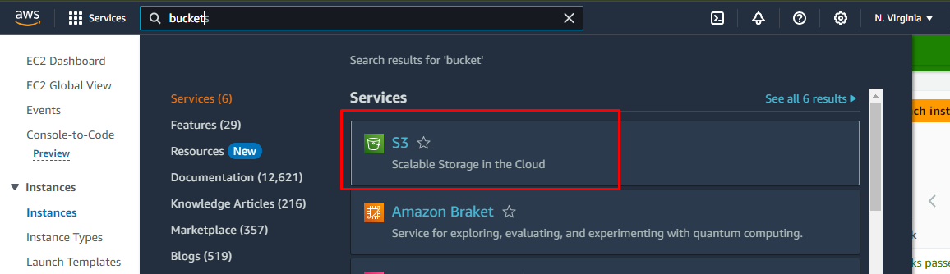

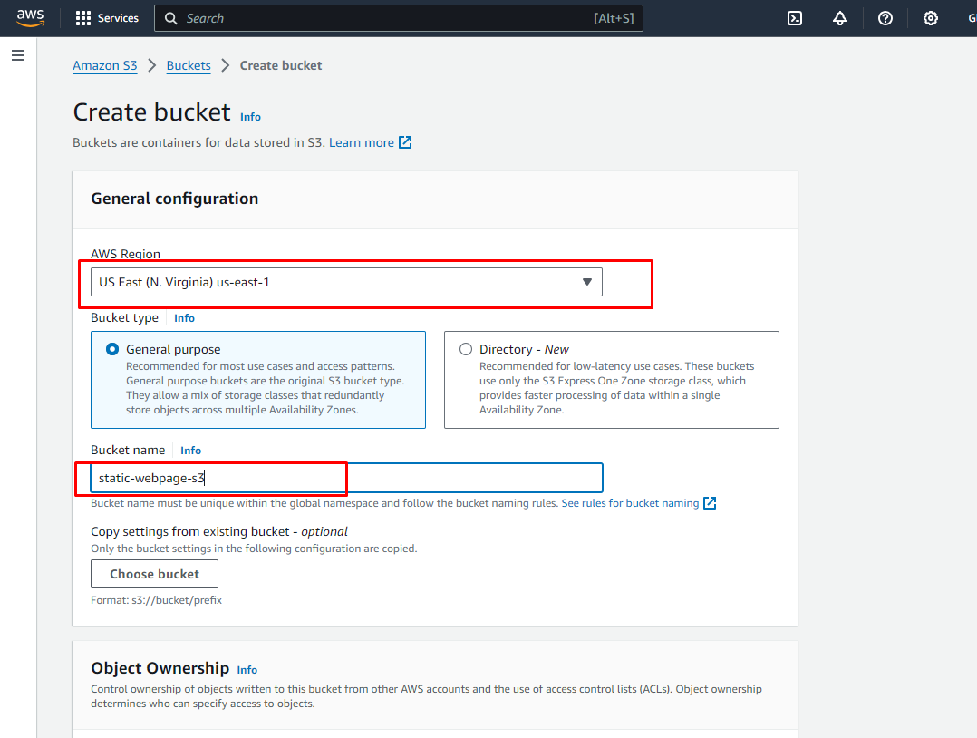

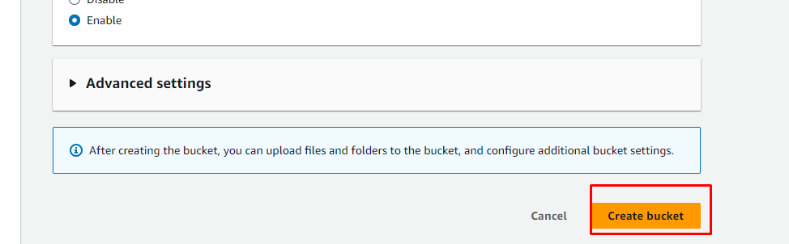

**Step 2 : Enable static website hosting**

* First Under Properties, we scroll all the way down in end of the page we have “static Website Hosting”.
* We can see that is currently Disabled, so we have to Edit it.
* Select enable
* Select “host static website”.
* Write “Index.html”.
* Then click on “Save changes”.

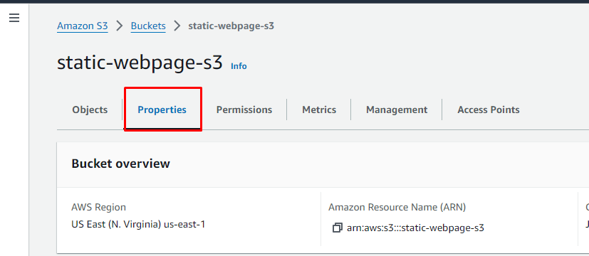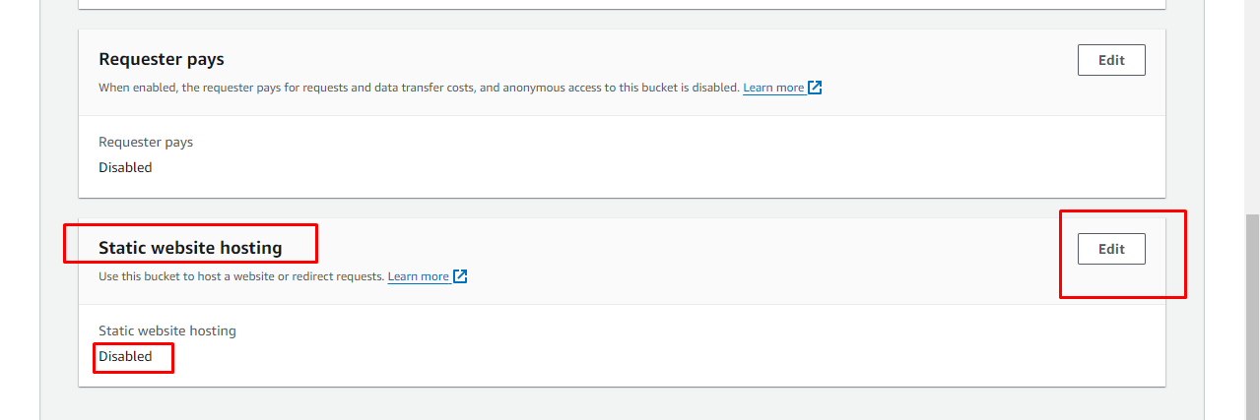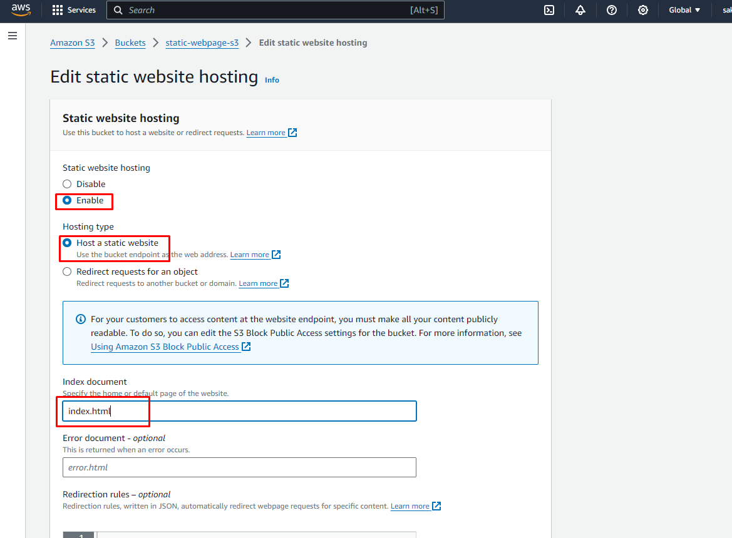

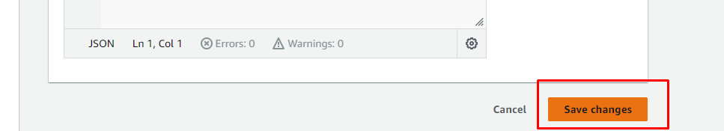

* now we can see that here in the static website hosting section link is available if we check by running that url link on your browser we can see that access is denied that’s because by default all public access is denied.

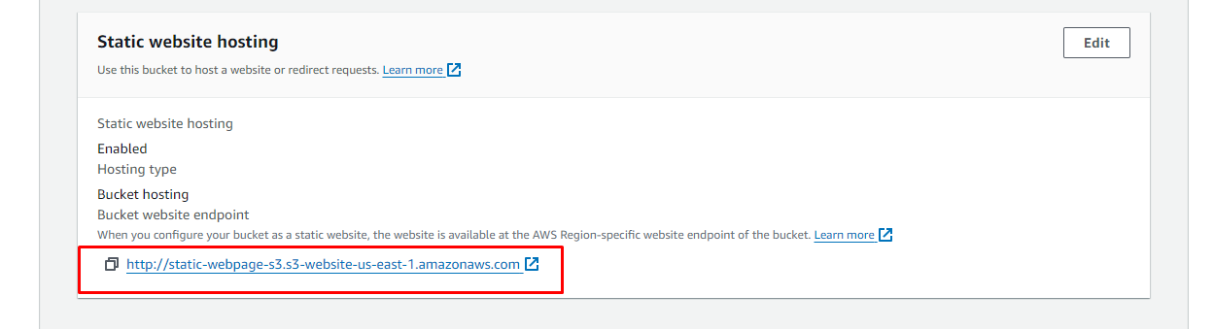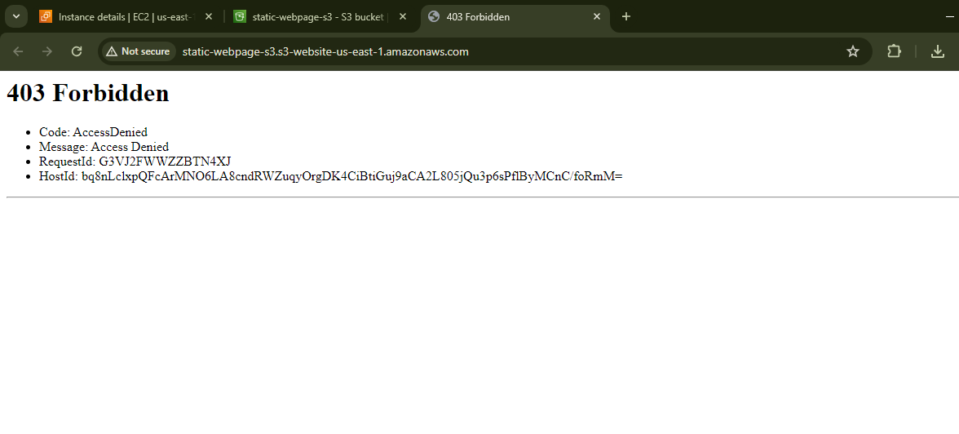

**Step 3: Public access**

* Under permissions
* Click on Edit
* Block all public access we will unselect this.
* Click on “save changes”

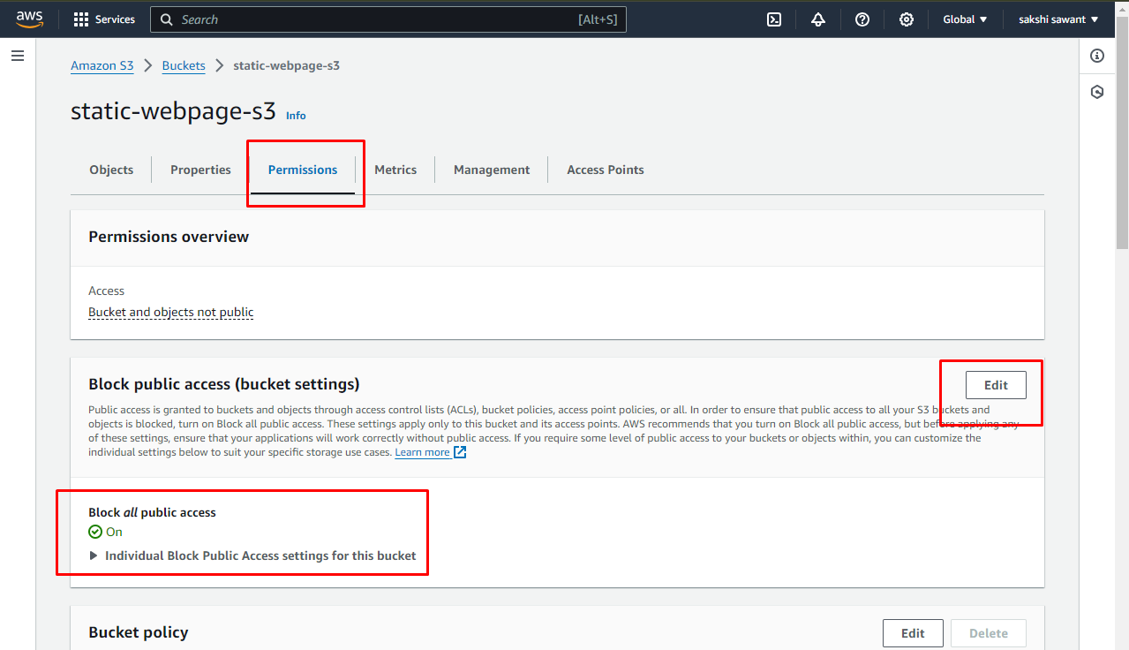

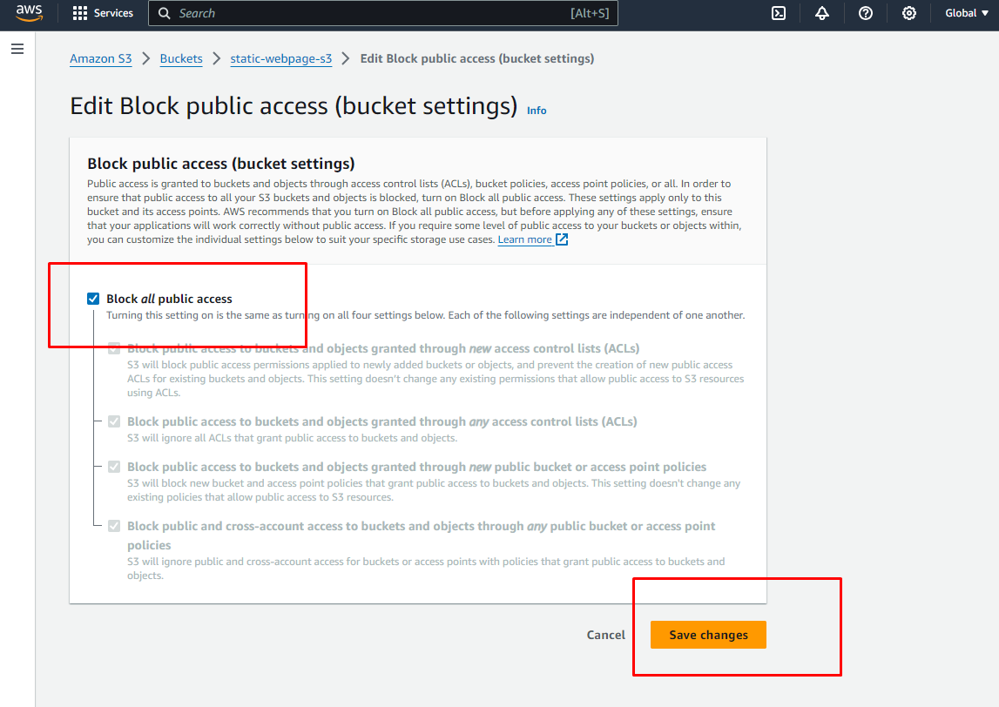

* We will be asked for confirmation for disabling block public access
* Then we can see that “Block all public access” is off

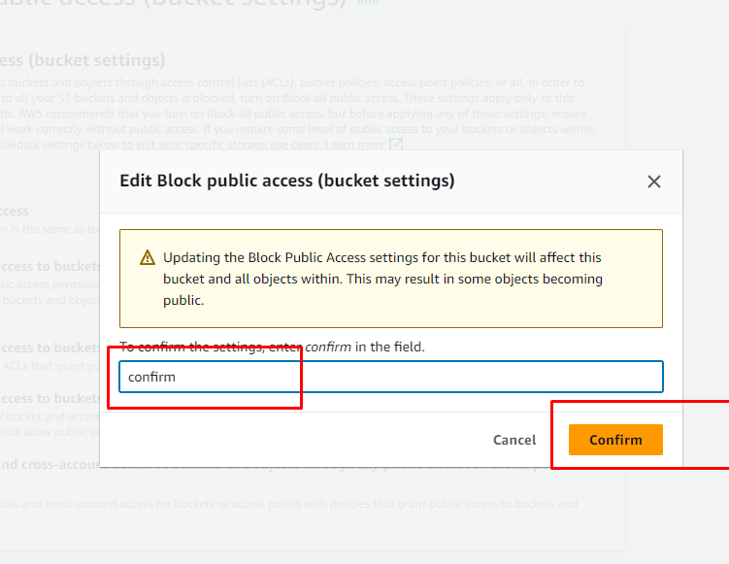

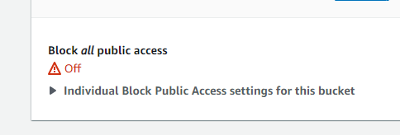

**Step 4: Add Bucket policy**

* We have to add bucket policy so that the content of the s3 bucket can be publically accessible.
* First we will go to Permissions and the in bucket policy section click on “Edit”.

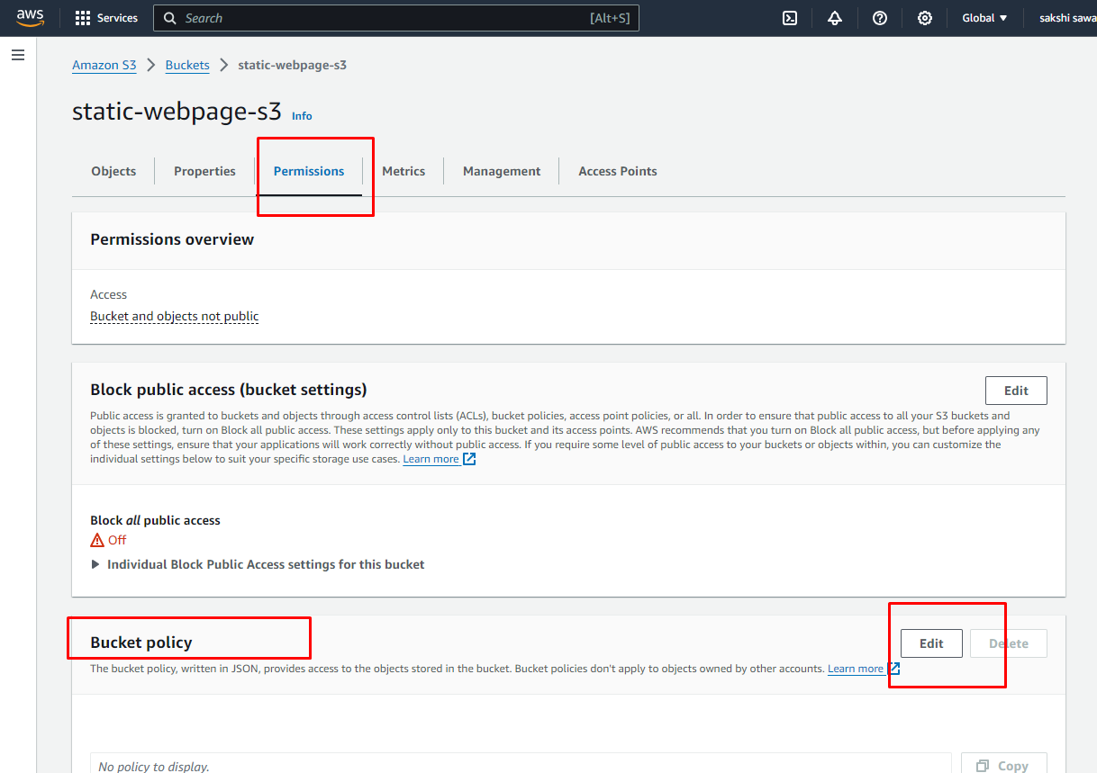

* “Select type of policy” as “S3 bucket policy”
* Effect – “Allow”
* Principle – “*”
* Action- “Getobject”
* Amazon Resources Name (ARN) you will get this from your S3 just paste it and add /* with it in the end means get everything on your bucket
* Click on Add statement abd then click on Generate policy .Copy that code to your bucket policy

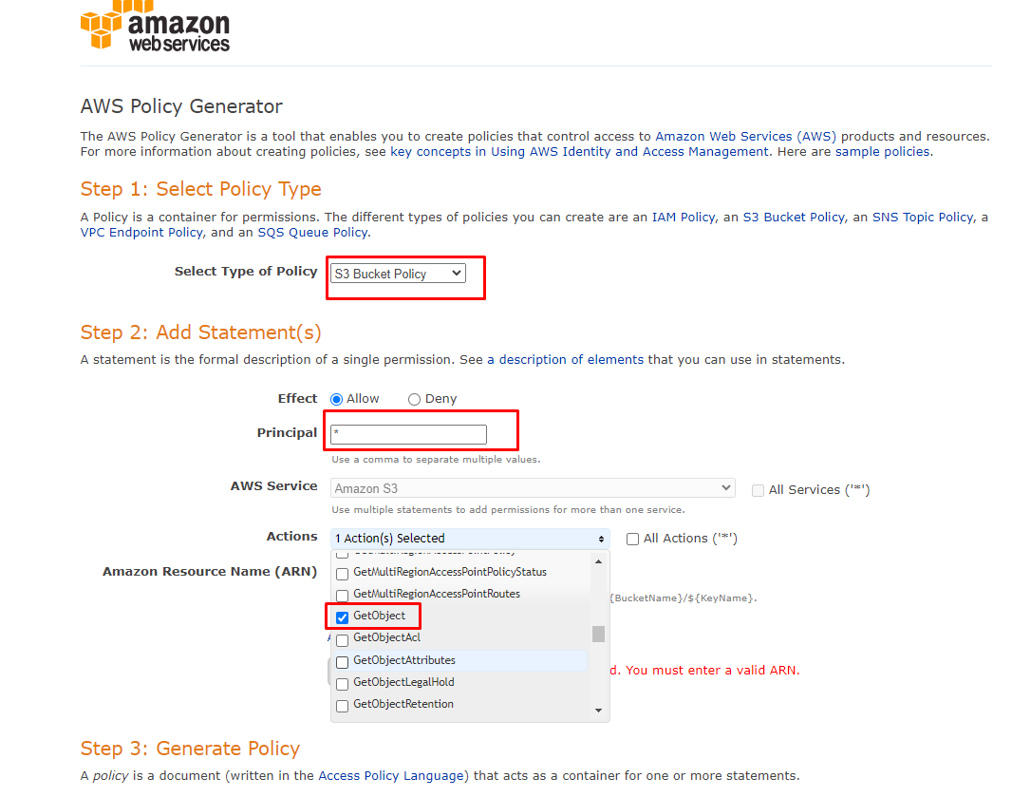

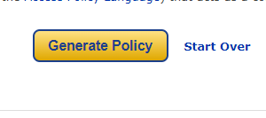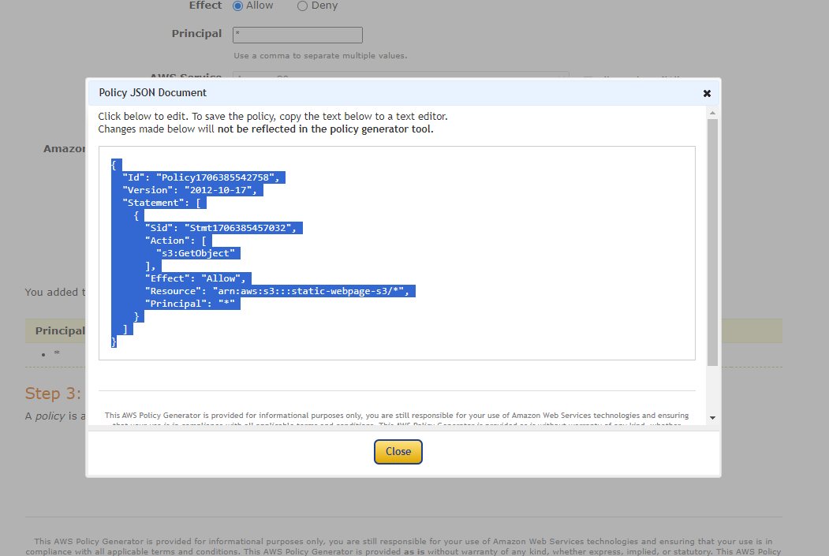

* Now paste it here in Edit Bucket policy

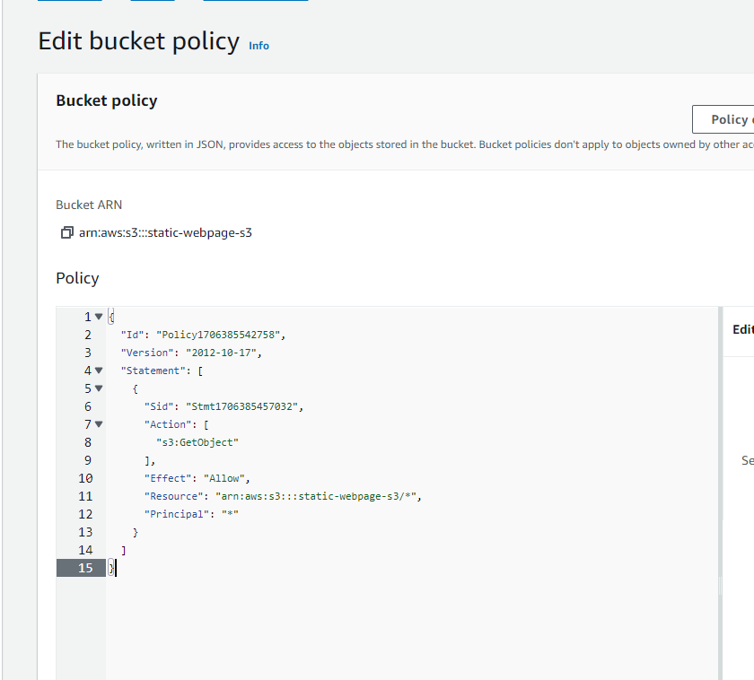

**Step 5: Add file to your object**

* Go to “Objects”
* Click on Upload to add your file and hit on “Upload”

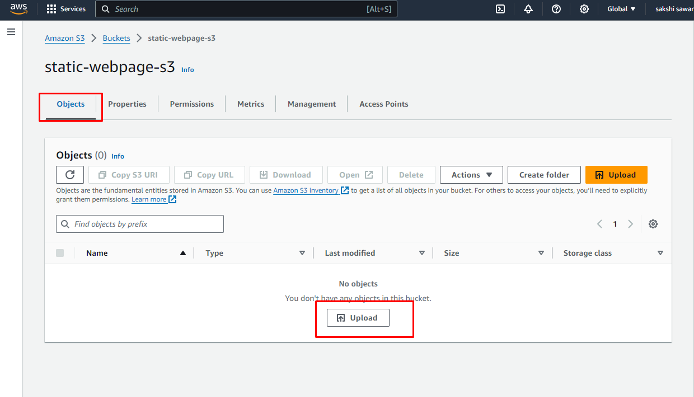

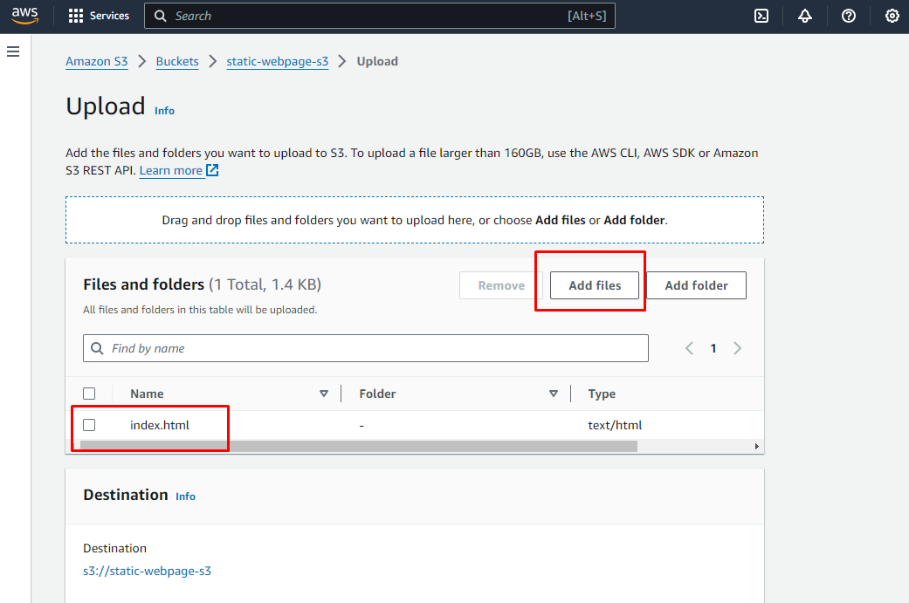



* we can see all the file are been uploaded now let’s check out the output let’s see if we can see our webpage on our browser

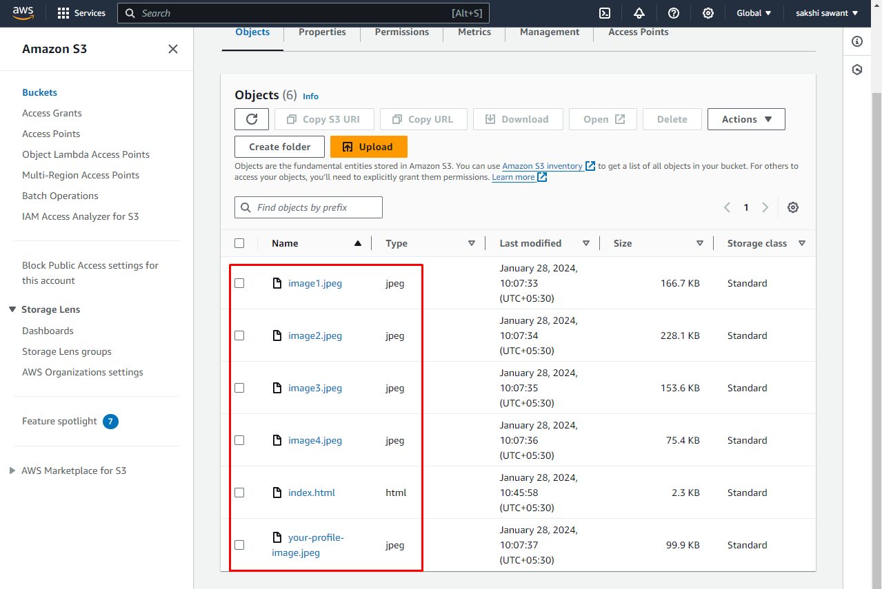

**Step 6: Check the website**

* Go to permissions
* Copy the static website link
* Paste that link on your browser

